**SQL ASSIGNMENT ANSWERS**

**PART A**

Database and Table creation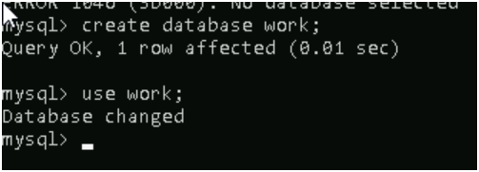

Question 1

Question 4

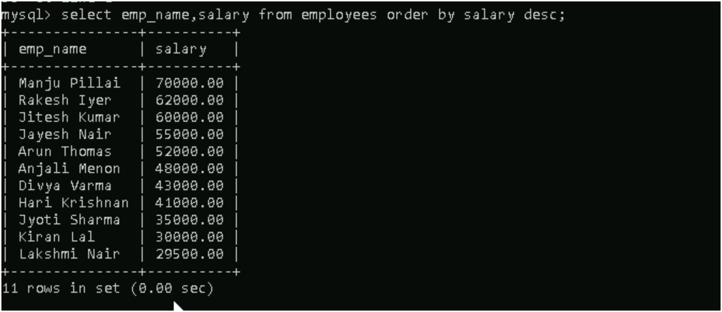

Question 5

**PART B**

Question 7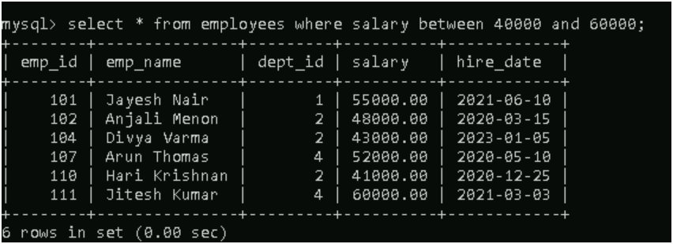

Question 8

**PART C**

Question 9

Question 10

Question 11

Question 12

**PART D**

Question 14

**PART E**

Question 16

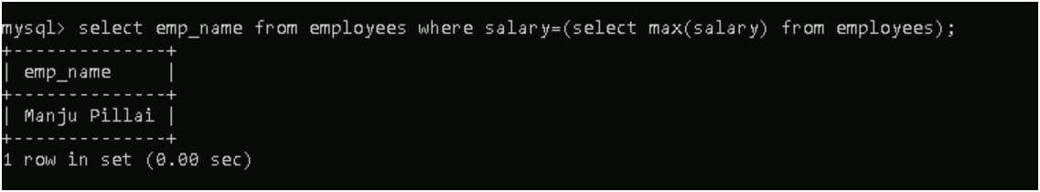

Question 17

Question 18

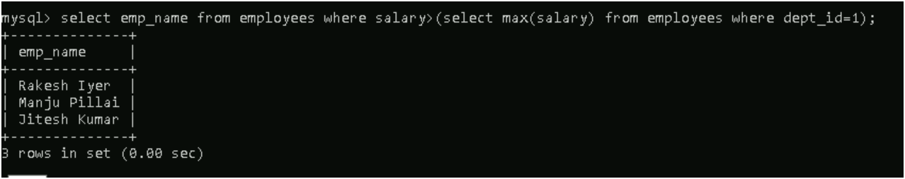

**PART F**

Question 19

Question 20

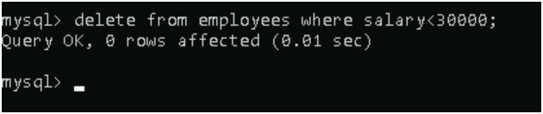

**After update no records having salary less than 30000